**NESTLE SQL JOB [**Prod Secondary DB Server with name **Nestle_Prod_Mirror]**

**By Rahul Badola**

**Dated: 17/Jan/2024**

The main purpose of the NESTLE SQL Job is to publish project metadata and financial information to build analytics data sources. This process runs on a mirror database to create tables for the reporting database. Let's break down the key components of this job description:

* **Publishing Project Metadata and Financial Information**: This suggests that the job involves making project-related data, including metadata (information about the data) and financial details, accessible and available for analysis.
* **Building Analytics Data Sources**: The job focuses on constructing data sources specifically designed for analytics purposes. This could involve structuring and organizing the data in a way that is conducive to analytical queries and reporting.
* **Running on a Mirror Database**: The use of a mirror database indicates that this process is likely carried out on a replicated database that mirrors the original. This can be a way to perform these operations without affecting the live or production database.
* **Building Reporting Database Tables**: The end goal is to create or update tables in a reporting database. These tables are likely designed to facilitate reporting and analysis, providing a structured and organized view of the project metadata and financial information.

In summary, the main objective of this job is to enabling effective analytics by preparing and structuring project data in a reporting database. The use of a mirror database suggests a cautious approach, ensuring that the operational database is not directly impacted during these processes

**JOB Step 1: Publish Projects**

Build Following Tables from **TAB_PROG_UPDATE_DATE**

1. BI_EXPOSURE_PROJ_UPDATE
2. SQL_EXPOSURE_PROJ_UPDATE

|  |
| --- |
| insert into [NestleSQL-prima].Nestle.dbo.SQL_EXPOSURE_PROJ_UPDATE  select c_prog , getdate() from Nestle.dbo.PROG_T056 where c_prog in (select a.c_prog from Nestle.dbo.PROG_T056 a  inner join Nestle.dbo.TAB_PROG_UPDATE_DATE b on a.C_PROG = b.c_prog where  (isnull(b.LAST_UPDATE_DATE,'') > isnull(a.PUBLISHED_DATE , '') )) |

Then publish the cost of modified projects only with below procedure, these are called from Nestle_Publish DB as secondary DB is read-only, mirrored with Primary DB server through Azure .

|  |
| --- |
| exec PublishCosts @progid |

**JOB Step 2: PublishReports**

**Currently following tables are getting build**

1. **PROJECT_PIVOT_REPORT** from **PublishProjectPivotReport**
2. **PROJECT_PIVOT_REPORT_SPECIAL_CHARGES** from **PublishProjectPivotReport_S_Charges**
3. **ASCN_Group_OBS**
4. **ASCN_OBS_PROG**
5. **STRU_SIST_T094**
6. **UTEN_T017**
7. **PROJECT_PIVOT_REPORT_Y_2** from **Fun_reportingprojectmetadataphasingcapex**
8. **PROJECT_PIVOT_REPORT_SPECIAL_CHARGES_Y_2** from **Fun_reportingprojectmetadataphasingopex**

**JOB Step 3: Register SQLDS**

1. **ProjectRegisterMetaDataSQLDS** from **dbo.Fun_ProjectRegsiterSQL**

**JOB Step 4: PublishAtlasReport**

1. **Tab_Atlas_Report** from **View_AtlasData**
2. **Tab_Atlas_Report_LC** from **View_AtlasData_LC**
3. **Tab_Atlas_Report_USD** from **View_AtlasData_USD**

**JOB Step 5: CashFlowReport**

1. **NestleCashReportByWBSByMonth** from **SQL_Fun_CashReport_ByWBS_ByMonth**
2. **NestleCashReportByWBSByMonth_US39** from **NestleCashReportByWBSByMonth_US39**

**JOB Step 6: SQLDS-YEARLY**

1. **NestleProjectYearlyCostSQLDS** from **Fun_DashboardReportCostDataWithAnnualPhasingSQL**

**JOB Step 7: SQLDS**

Build all the data sources managed through **Reporting API** and table **DashboardReportingDS**

select * from DashboardReportingDS where DS_Enable =1

EXEC **SynchMetaDataReportingDatabaseSQLExposure** 'https://nimtdashboard.po-live.com/NIMT_REPORTING_API', -1, 'YmxJT2xTaTcvRUhncElGVEl6V2V3bmlkZUIvYUoxN1Y0OWRnVEZNWTFlbz06R2xvYmFsIEFkbWluaXN0cmF0b3I6NjM4MDc3MDk3MjYxNDU1NzcyOjA='

**JOB Step 7: ArchivePublish**

Build all the Archive **data sources** managed through **Reporting API [Power BI]** and table **SnapShotDashboardReportingDS**

select * from SnapShotDashboardReportingDS

EXEC **SynchMetaDataArchiveReportingDatabase** 'https://nimtdashboard.po-live.com/NIMT_REPORTING_API', -1, 'R25vMEZCWGtQQUpJb3MwYVVvWERGTkVkdUpFWXJ3aExETjZ3U05WWFJlbz06R2xvYmFsIEFkbWluaXN0cmF0b3I6NjM4MDc3NDA4OTgwMDg3OTg1OjA='

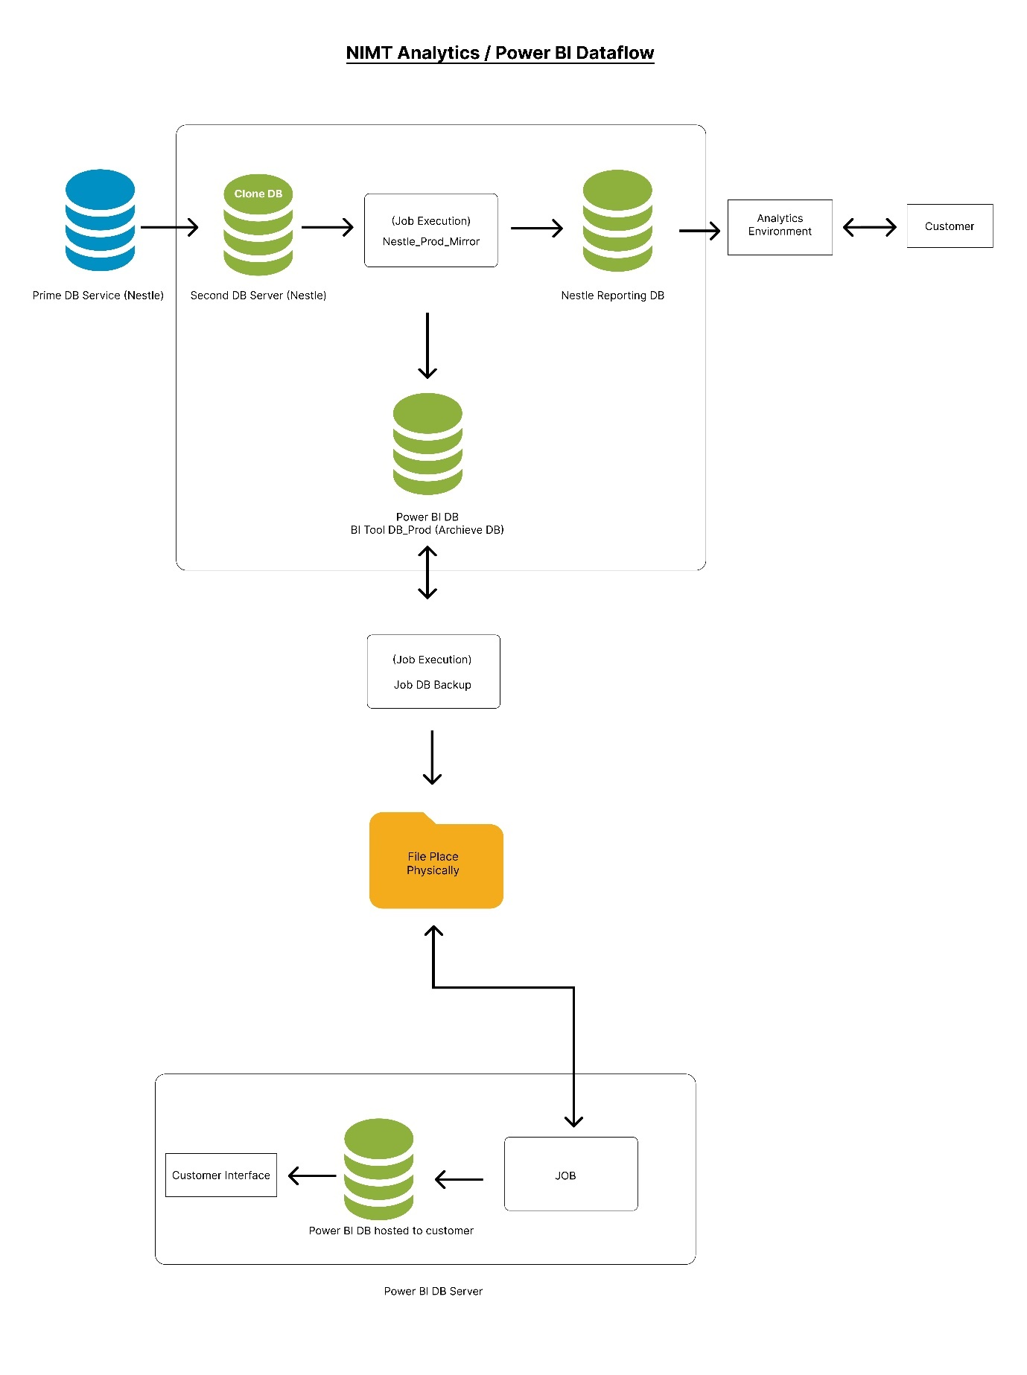

**NIMT Snapshot JOB (**SnapShotPublishedData**)**

Apart from this Nestle also has the Quarterly Running Snapshot Job, which Run on every 3 months 1st day.

select * from SnapShotDashboardReportingDS

|  |
| --- |
| EXEC **SynchMetaDataSnapShotReportingDatabase**  'https://nimtdashboard.po-live.com/NIMT_REPORTING_API', -1, 'R25vMEZCWGtQQUpJb3MwYVVvWERGTkVkdUpFWXJ3aExETjZ3U05WWFJlbz06R2xvYmFsIEFkbW  luaXN0cmF0b3I6NjM4MDc3NDA4OTgwMDg3OTg1OjA=' |